Emerce

b01_team4 PBL CMPS 312 FALL 2022

Mohamed Ahmed Abdalla Ahmed (201904161)

Ahmed Abdelhamid (201907476)

Ahmed Alobahi (201707769)

Hani Jafer (201908619)

Syed Zubair (201708606)

Contents

Motivation **Error! Bookmark not defined.**

Initial GUI Design 3

Final Implemented Design 13

Database Design 28

Design and Architectural Patterns 30

Implementation 32

Additional Features 41

New Gained Knowledge and Skills 41

Reflections 42

Resources 45

Appendix A: Json Files 46

# Motivation

Stores nowadays are in a severe need for new ways to reach customers, as the classic physical shop idea is now outdated. A digital frontier should be adopted to reach the audience, in addition to a lot of added values, such as convenience, efficiency, security and much more. Some advantages of having an application for a business includes:

* Convenience: Users may explore and buy items from their phone or tablet anytime, anyplace, making it more convenient and quicker for them to shop.
* Increased sales: By making it simpler for users to identify and buy things, a well-designed and user-friendly app may contribute to a rise in sales. To entice users to purchase more regularly, an app might also provide supplemental features like personalized suggestions or reward programs.
* Competitive advantage: Provides customers with a distinctive and unusual shopping experience, giving the firm a competitive edge over its rivals.
* Consumer loyalty: By offering a smooth and delightful buying experience, it promotes customer loyalty. Users of the app could be more inclined to come back and do business with the company again in the future.
* Data analysis: Offers insightful information about consumer behavior and preferences that may be utilized to enhance the shopping experience and inform corporate choices.

Overall, developing an Android shopping app can be a great way to increase convenience and sales, build customer loyalty, and gather valuable data for a business. As a result, the project’s objective is to develop a digital store, an android app that showcases different products and provides the framework to shop and buy those products, to be delivered to the customers doorsteps, without them taking a step out of the door.

# Initial GUI Design

|  |
| --- |
| **User Interface Design** |
| Using Balsemiq, we collectively designed a low fidelity design.  We made our screens design based on the use cases that were given and we took inspiration from famous apps that has a modern design and an easy interface to use. We made sure that the user experience made sense to the end user. |
|  |
|  |
|  |
| Product Details Product Reviews Add Product |
| Shape, polygon  Description automatically generated  Order Details  Payment Mode |
| A picture containing graphical user interface  Description automatically generated  Edit Product  Shopping Cart  Order Summary |
| Diagram  Description automatically generated  Add/Edit Address |
| Graphical user interface, application  Description automatically generated  Track Orders |
| Edit Review  Delete Review  Shape, rectangle  Description automatically generatedA picture containing graphical user interface  Description automatically generated  Add Review  Graphical user interface  Description automatically generated |
| Dashboard   |
| Graphical user interface  Description automatically generated  Admin Orders Screen & Order Details Screen |
| Diagram  Description automatically generated  Reports |

Track Orders

# ­Final Implemented Design

There is not a lot of differences between the intended design and the implemented design, changes present are minor design choices that offered a better user experience or was more familiar for development. There have been cases where we changed the design because we thought that the initial design was a bit challenging for us since we were new to kotlin and learning jetpack compose took some time as well as it required good understanding and practice of the layouts and components.

|  |  |
| --- | --- |
| Screen | Screen Design |
| **Login** |  |
| **Register** |  |
| **Forgot Password** |  |
| **Verification OTP** |  |
| **Reset Password** |  |
| **Admin Home** |  |
| **Normal User Home** |  |
| **Admin Product List** |  |
| **Normal User Product List** |  |
| **Product Details** |  |
| **Cart** |  |
| **Place Order** |  |
| **Track orders** |  |
| **Order Details** |  |
| **Manage Address** |  |
| **Add Address** |  |
| **Edit Address** |  |
| **Manage Review** |  |
| **Add Review** |  |
| **Edit Review** |  |
| **Manage Product** |  |
| **Add Product** |  |
| **Edit Product** |  |
| **Profile** |  |
| **Admin Dashboard** |  |
| **Admin Report** |  |
| **Admin Report Filter** |  |
| **Admin Update Order Status** |  |

# Database Design

We used Lucid Charts to design the database which allowed us to make the diagram using the pre made component the app provides.

Our design was influenced by the use cases and the user experience that we decided on, it served as the proper development transition from the design phase. We introduced every component of the system that we thought of, and we introduced approaches that facilitated the implementation of these concepts programmatically. Having the class diagram was very useful, it helped us to understand how to make the entities and what fields we needed to include in them so that the app will function properly. We tried to keep the data as clean as possible by making use of foreign keys when required so that we can refer to the data using joins and not include redundant data in the database which adds unnecessary data to the database. When designing the database we saw some similar examples online to see how different apps implement the database, using some examples as good reference we managed to come up with the following design.

# Firebase

Firebase is a development platform used in mobile and web development. It comes with many cloud technologies that can be used to deliver the product. In our project we have used the Firestore which is a no SQL document database that is used to store query data and sync across mobile and web apps. The data in Firestore is stored in documents which is part of a collection, multiple collections were used to make the application work. This is the first time we have implemented a database on the cloud Firestore and integrated it with a mobile application and to initialize the data on the Firestore we used the retrofit library. We learned how to query data from the database as we had to basically replace all the Room Dao functions.

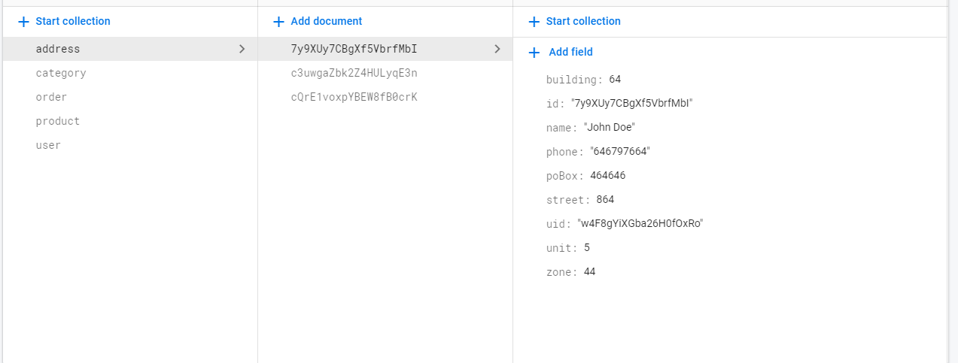As you can see the collections in the first column and each collection shows the documents which exist in that collection and finally shows all the data in the last column which represents the data existing in the unique document.

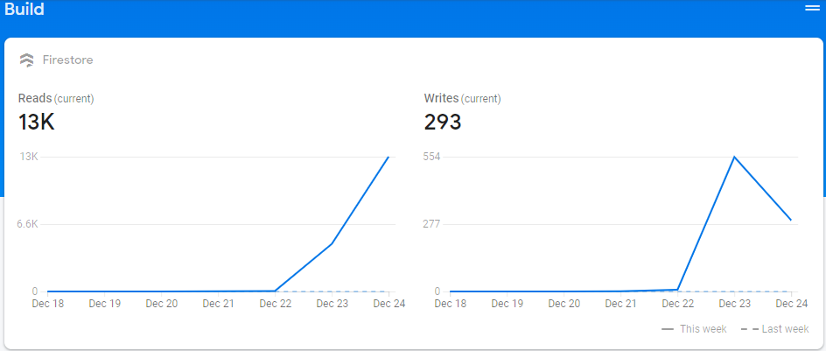

Here is a brief overview of the reads and writes to the Firestore,

# Design and Architectural Patterns

The Model, View, View-Model (MVVM) is a software architectural pattern used to design different kinds of software. It is a widely used pattern since it has many benefits. This pattern is like the MVC pattern, and in fact is another version of the MVC pattern.

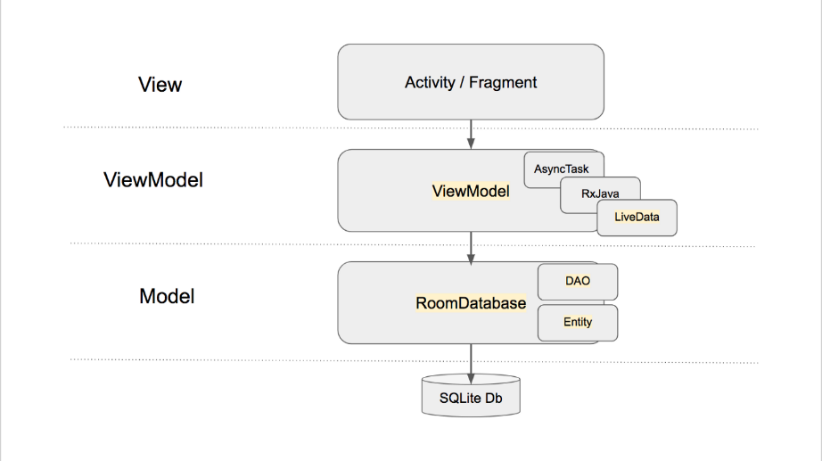

The MVVM’s main feature is to separate the concerns of the app into 3 different layers which have different kinds of responsibilities associated with each one.

These are separated as follows:

1. Model: The model represents the data and business logic of the application. This may include the repositories, objects etc.
2. View: The view has the responsibility to show the UI to the user, it includes the ui components and screens which make up the application user interface.
3. ViewModel: The ViewModel has the responsibility to handle the states used in the view and to manage the data required by the view. This means that the ViewModel interacts with the repositories directly and passes the information as state in the view.

The benefits the MVVM pattern gives are that it creates a separation of concern and this allowing the development of the apps to be easier. It helps to structure the application in a clean manner which will be easy to maintain and scale as well. For example, when we started to use this pattern, we realized how easy it was writing the code for different screens as the pattern was easy to understand and follow. We managed to maintain the code well and it was easy to spot errors when the rose.

There were a few disadvantages to using the Model-View-ViewModel (MVVM) architectural pattern:

* Complexity: The MVVM pattern adds an extra layer of complexity to the app development process. It requires a clear understanding of the responsibilities of each component and how they interact with each other, which can be difficult for us as new developers.
* Lack of flexibility: The MVVM pattern can be inflexible in certain situations, particularly when it comes to handling complex UI logic or handling data that does not fit neatly into the Model-View-ViewModel structure.

Overall, while the MVVM pattern can provide many benefits in terms of structure and organization, it is important for developers to carefully consider whether it is the right fit for their project and to be aware of any potential disadvantages.

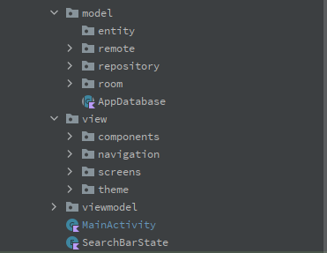

Here it can be seen that in our file structure we used the MVVM pattern. All out screens come under the view and navigation is also a part of the view. Our model hosts the business logic and data of the application, we used room database in the phase 1. In the ViewModel directory we had the viewmodels for each of the screens.

# Implementation

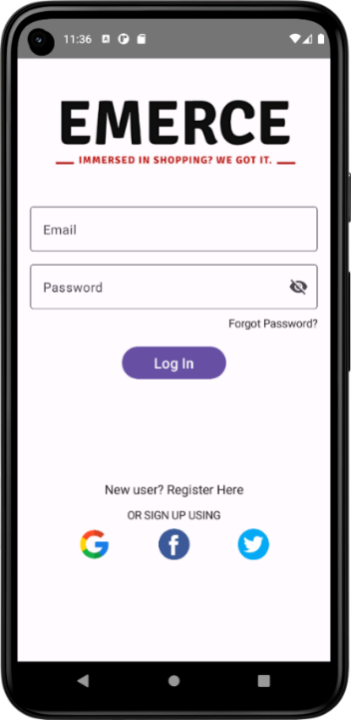

1. Login

When launching the app for the first time, you will be directed to the login screen, where the user can login to the home page given his account is stored in the database. When the user enters the correct password then they are taken to the home page to see the products, however, if they enter the incorrect details then it will indicate the user that the details are not correct, and the user can retry again.

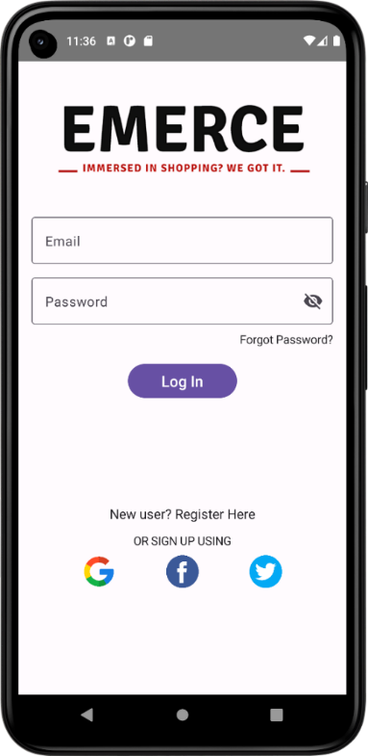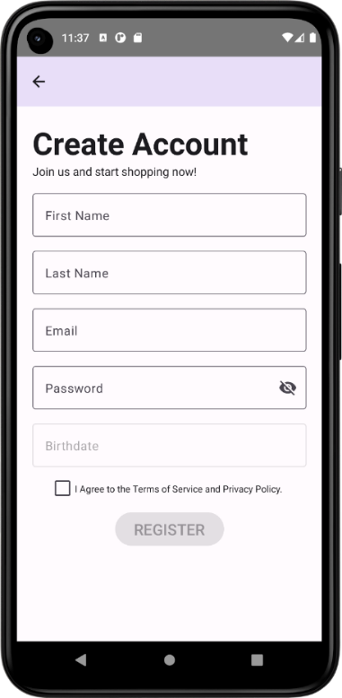

1. Register

If the user does not have an account, he must register by providing his details then agreeing to the terms and conditions. Once the user clicks on the register button the details will be added in the database if the validations are met, however, if they are not met then the user will need to fix the issues and click the button again. The user will then be redirected to the login screen to login.

1. 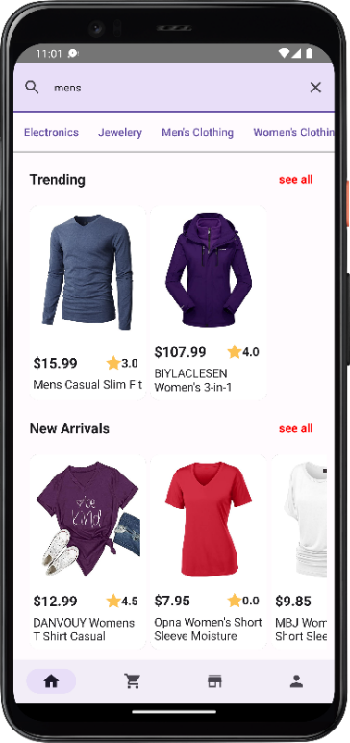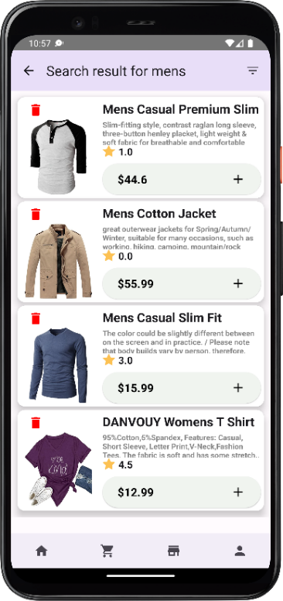Filter Products

Users can filter products in the home screen by using the search bar to search for products, once they apply the search, they will be directed to the product list screen in which the result will be shown. If users want to filter by price, category or rating they can click on the icon top right in the product list screen.

As you can see, the user asked to see only men’s clothing with 1 stars and up rating. These items can be added directly to the cart as well.

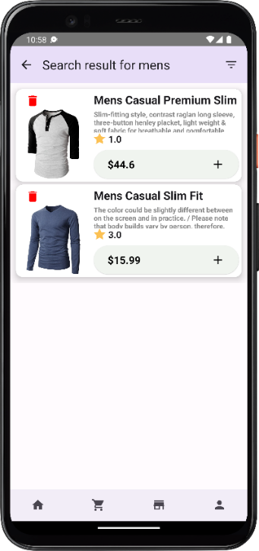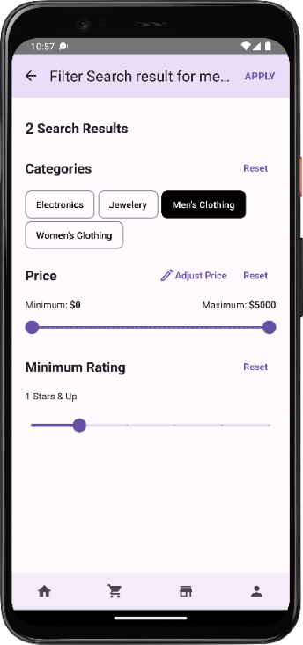

1. 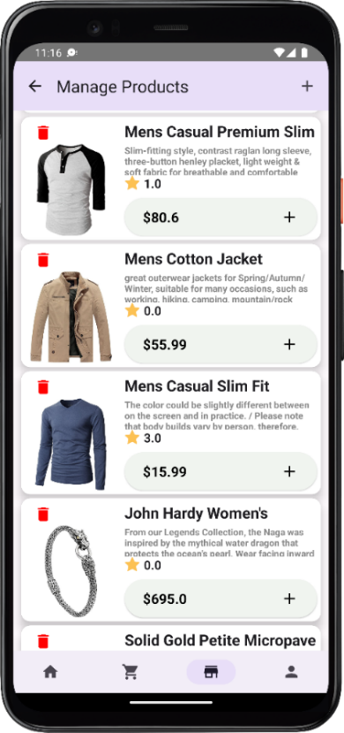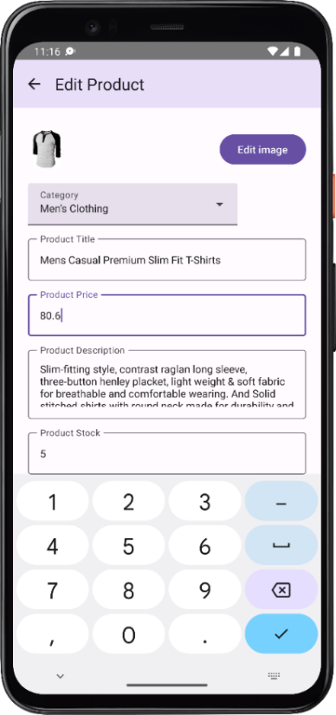Update Product (Admin)

In the manage product screen, Admins can update the product’s information by clicking on the product card. The admin updated the price to 80.6 and changed the description as well as the quantity of the stock.

1. 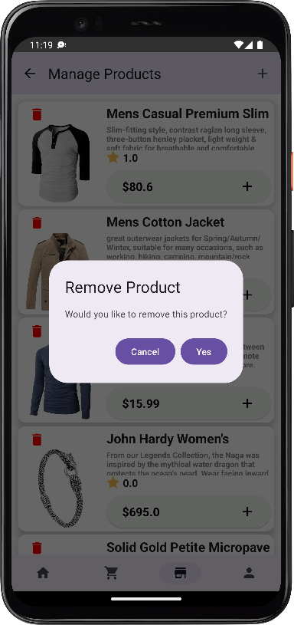Delete Product (Admin)

Admins can delete a product by clicking on the trash icon in the product card. This is delete the item from the database and will now show in the catalogues anymore. As it can be seen the men’s casual premium slim tshirt is no longer visible in the list.

1. Add Product (Admin)

Admins can add products by clicking on the add icon top right. The admin here entered details of a shoe and added an image of it. Once the admin clicks the add button the product gets added in the database and the users can see the new shoe in the application as well.

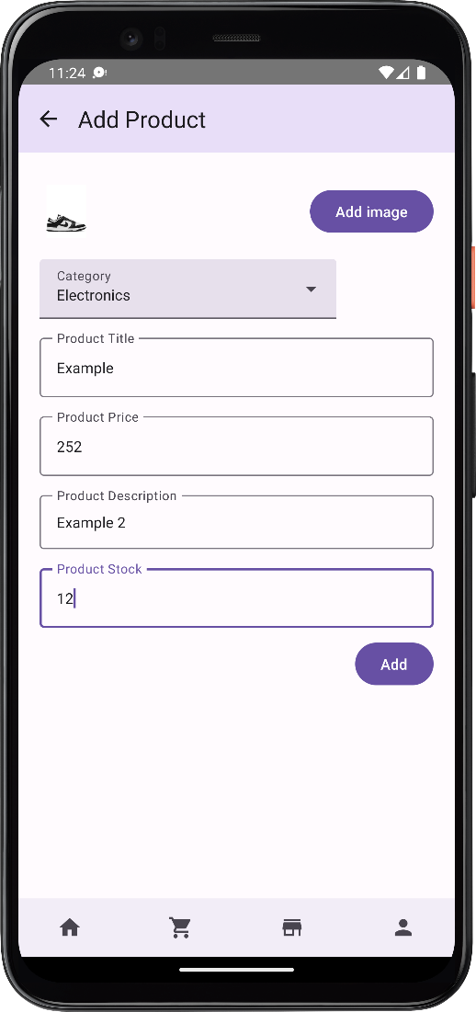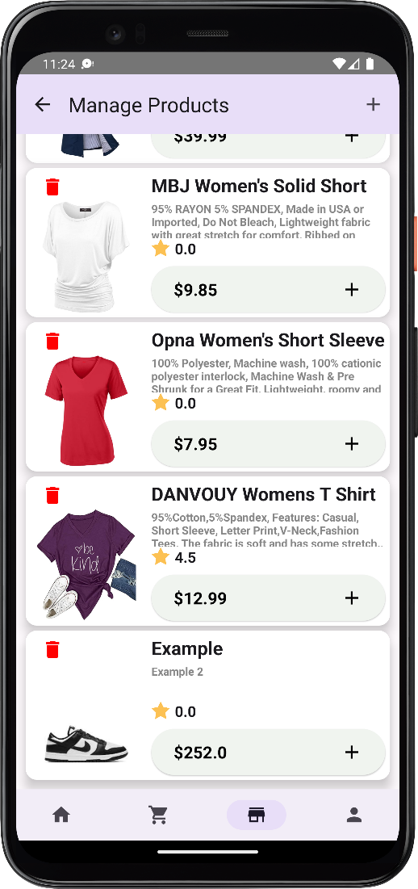

1. View Products

Users can view specific products by clicking on different categories at the top or by clicking on "see all” for a featured product. The home page has different sections such as ‘Trending’ which gets the most purchased items, ‘new arrivals’ which gets the latest added products in the app. The category specific items can be viewed as well when clicking the category chip located below the search bar. The search bar also returns the products which contain the query searched for.

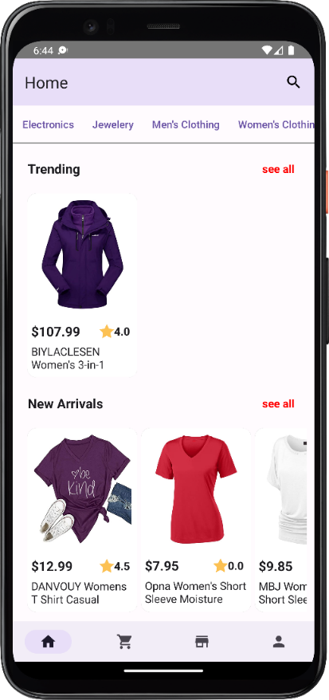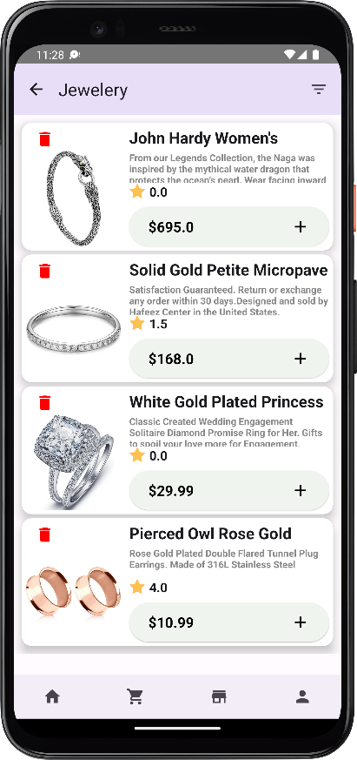

1. View Product details

Users can check a product detail by clicking on the product. This will show the user the title, image, description, and reviews if any of the product. The user can select the ‘add to cart’ button from here and it will ask whether to continue shopping or go to cart directly.

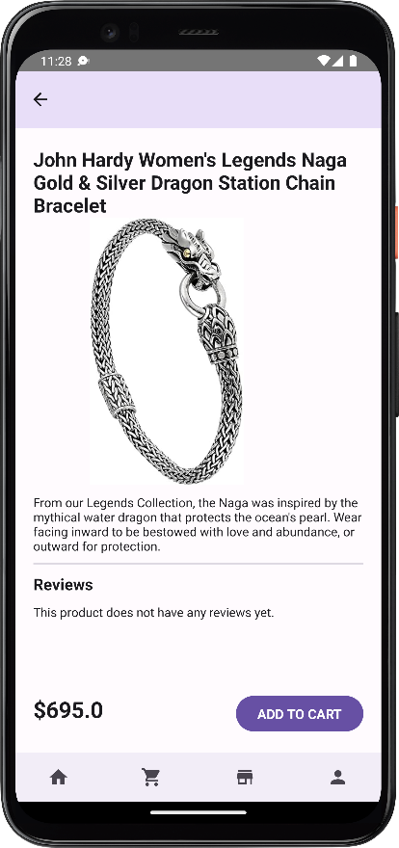

1. Cart

Users can add products to cart directly by clicking on the plus button in product list screen or by clicking on the add to cart button in the product details screen. If the user clicks on the plus button, then more quantity of the product will get added. Depending on the user level, the user gets a discount on the final total amount which will show the grand total after the discount.

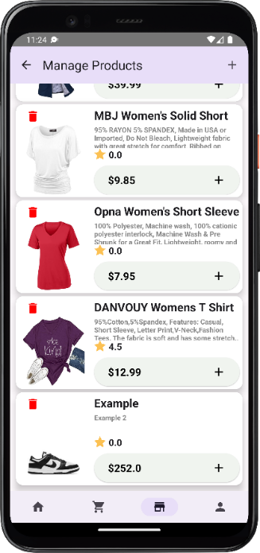 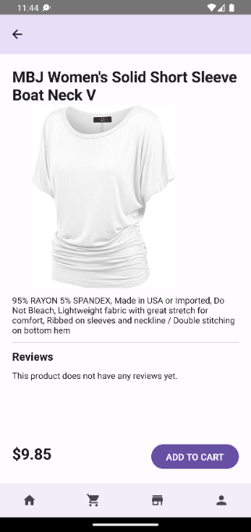 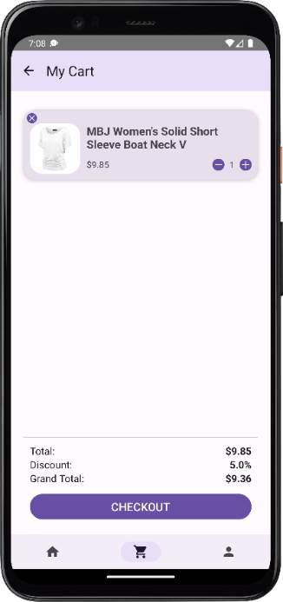

Users can delete a product from cart by either clicking on the X icon or by reducing the quantity to 0. When it reaches to 0, the product will no longer be shown in the cart items.

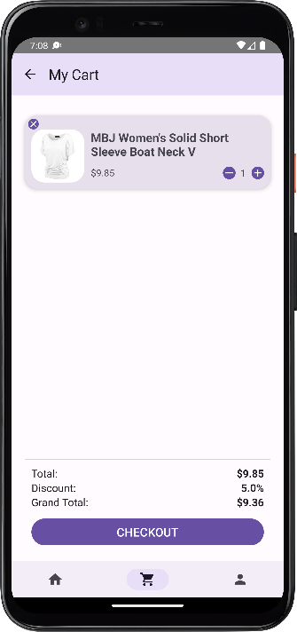 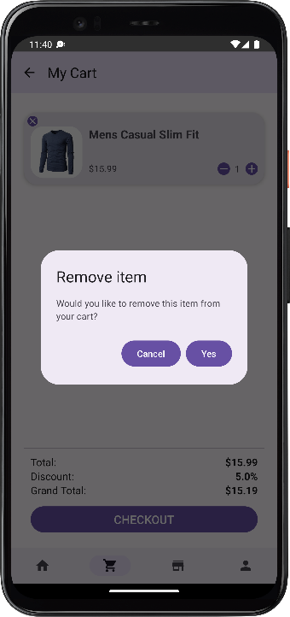 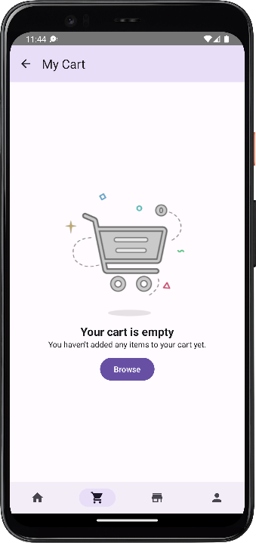

1. Place Order

To place an order, the user must add the product to cart then choose the quantity then select the address and the payment, the user will have the order summary and can confirm the order by clicking on the place order button.

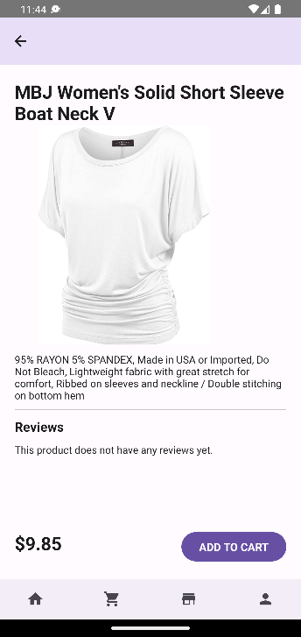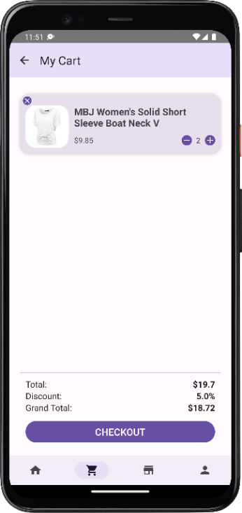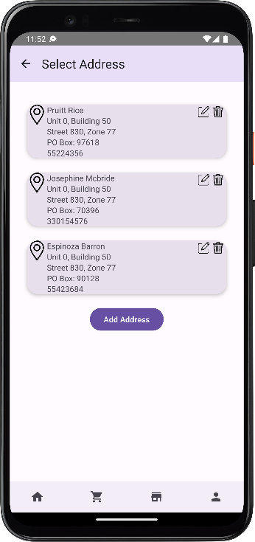

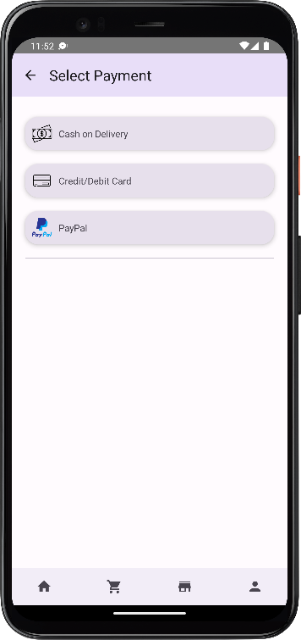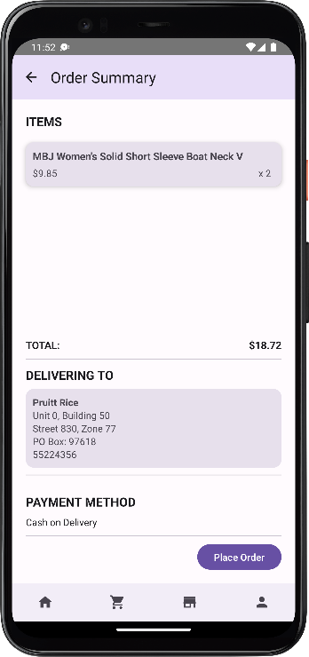

1. Review

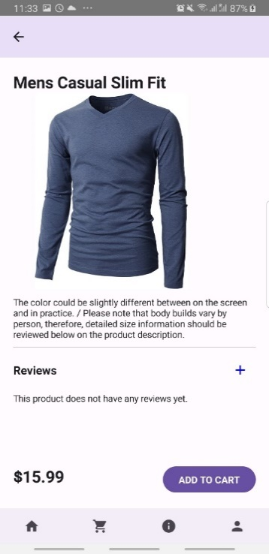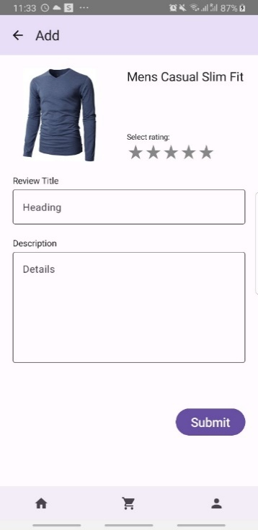Users can add, edit and delete a review when the product has been delivered. When the user has added no reviews the add title will show indicating it is the first time the user is trying to review the item. Once the review is added, the item will show in the product details page. When user goes back to the order details and goes to the reviews then they can now see edit this time

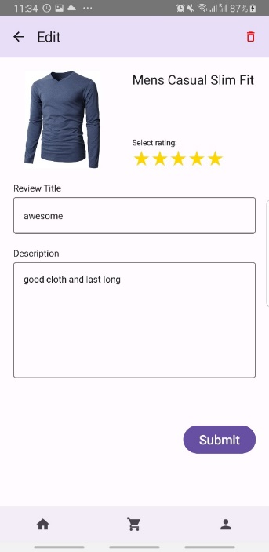 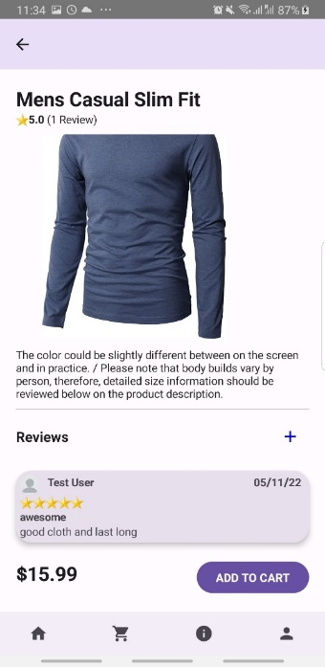

# Additional Features

**Forgot Password feature**

The ability to reset a user’s password if the user forgot his password, very important to the user experience.

**Search Bar**

A search feature for fast access and specific needs rather than wasting time navigating through different menus to find a product.

**User type (Loyalty program)**

We have allowed a loyalty system which allows users to be classified into different types such as New, Silver or Gold. These user types come with the benefit of discounts on orders. As users progress through different tiers of types, the discount increases. The user type is based on the number of orders. Once a user has placed atleast one order, they’re upgraded to the Silver type. After they’ve completed 5 orders the user is upgraded to Gold type. We believe such a system will encourage users to order from our application more and therefore drive more business based on user loyalty.

**Product Highlights (Trending, Top Ranked and New Arrivals)**

Exhibiting product highlights as a business-oriented feature, it brings the users’ attention to specific products which can grow sales. Trending products, Top Ranked products and New Arrivals.

# New Gained Knowledge and Skills

Designing layouts for Mobile Design using Jetpack compose with Kotlin [1].

Implementing and following the MVVM Architecture. This was an architecture we only studied and came across before in other courses but never implemented it in any application.

Implementing Room DB. We had no experience with Room DB previously, but the query functions were very similar to what we have seen before.

In our product filter screen, we added the ability to filter the products by categories. This meant that at some point the user might not want to filter by categories which meant that we had to change the query for this filter. Using @Query in room DB, we discovered that it was not possible to pass different queries based on a condition as a string to @Query [2]. So as a result, this meant that we would have to duplicate the method so that we have two methods, one that filters by category and another without.

However, this seemed redundant. So, we looked for another approach and we found that room DB supports a feature called @Raw Query [3]. This feature lets us pass different queries based on a condition as a string parameter to a method called SimpleSQLiteQuery which implements the class SupportSQLiteQuery. The only downside we have found is that, @Raw Query will not check the SQL query at compile time so in case of any errors with the query it will be shown in run time instead.

# Reflections

***Ahmed Abdelhamid***

I struggled with understanding how the layouts (Row/Column) worked in jetpack compose as I was more used to the drag and drop of UI components in frameworks such as JavaFx, so the idea of writing the UI design using Kotlin code was not easy to figure out which resulted in me not achieving the layout of the design I wanted. Thus, I have read the documentation and watched few YouTube videos about how layouts worked. Then I took the initiative to further enrich my understanding by practicing with rows and columns each with different background colors, which as a result helped me understand and design the layouts I have wanted to achieve.

Implementing the Logic was also a big task that I also struggled to understand, the concept of one activity that recomposes on UI changes was different from the multiple screens method that did not have to deal with states but rather with normal variables, so the shift to using states was difficult at the beginning. However, the guides from YouTube, Documentations and the scaffolding sessions held by our course instructors helped me understand the concept of Recomposition and state variables as well as concepts like hosting the state in a viewmodel.

It was tough at the beginning to adapt to the idea of self-learning all the topics in the whole course but looking back now, overall, it was worth it, I have learned many things and it also helped me refer to the documentation which is important.

The thought of not completing phase 1, there were a lot of tasks that my team and I had to do such as designing the wireframe and implementing the designs and their logic along with their navigations and the implementation of the database. All this made me feel that it would be difficult to implement before the phase 1 deadline. Luckily though, by assigning proper deadlines, we were able to finish everything in time and at the same time we had extra time to add extra features to the project.

Take the course much seriously and start as soon as possible with the design wireframes and practice small design layouts at the same time.

***Syed Zubair***

Initially when the project started, I was having difficulties with the UI because Kotlin was new to me, and I didn’t have good understanding of jetpack compose. But slowly, I started to understand it more through the scaffolding sessions and online tutorials and resources which was recommended to us. After making the UI, it was difficult to understand where and how to implement the logic, but thankfully, the demos provided by the course instructors allowed us to understand the concepts better.

My overall impression of this PBL learning is that it helped us understand the ideas in mobile development more and fully allowed us to take on the responsibility of learning. And the good thing is that the experience gained in PBL Is applicable when learning anything new. It has already helped me in my web development and design course.

The most worrying thing about the PBL was that it was quite difficult to set goals for ourselves since we didn’t know how long it would take for a task to be completed etc. as a result, this caused delays. Also, it might be hard to understand where to get the correct knowledge from and how to implement it properly in the project as there are many resources, and each can have different ways of doing things so it might be a bit complicated to navigate through the vast number of resources online and deciding which code/implementation will work best.

If I were to go through this experience again, I would spend time on practicing the fundamentals and trying to actively learn whenever possible.

***Mohamed Ahmed***

Starting a new learning journey is of course a wide challenge in itself, dedicating time and energy to fully understand new concepts would push a person out of comfort. And that was the most significant challenge, pushing myself out of the comfort zone to fully grasp new concepts. It was also the most significant value that I deem precious to me, which is that to evolve and prosper, we shall seek discomfort. In a more specific technical manner, understanding the MVVM architecture and how it is formulated and how to follow it was particularly challenging, but given studying and practicing, MVVM architecture became familiar, and it helped facilitating the development process, both individually and as a team, I now understand its significance and appreciate it.

The PBL experience for me was a positive experience, I believe it is one of the best ways to learn new concepts. Going back to seeking discomfort, this experience pushed me to be an Android Developer, and of course it did, it pushed me to learn the concepts myself, practice it, and implement it in the project. The team spirit was present as well and the atmosphere of the collective learning and collective work was new and interesting, either of the Team or the lab sessions.

This experience being my first of its kind, I certainly had some concerns, concerns of getting stuck or not being able to deliver on time. But these concerns where dissolved by the instructor’s presence, there solid knowledge in the subject, and with my first experiences of undergoing an obstacle and successfully grasping the concepts.

At the end, I would say that I enjoyed this experience and will make sure to be more involved in the studying and facilitate the team-work harder and more efficiently if a similar experience presented itself in the future.

***Hani Jafer***

One of my biggest challenges was understanding how the view models will be integrated in the app. It wasn’t clear how the different screens would communicate with each other and how data would be sent throughout the app. The project flow guide helped us a lot in understanding the purpose and style of the view models to create them easily. I believe PBL experience is the best way to learn something in the development field. I am certain we wouldn’t have been able to make an app of this quality in this much time if we followed a classic learning approach. PBL is the method which should be followed in most CS courses if possible as it is very close to the real-life scenario of software developers. One of the things that worried me initially about PBL is that we had zero knowledge about the concepts going into it. I thought this would be a big challenge, but our instructors were always there to guide us through scaffolding sessions and flow helps which solved this issue. The experience was perfect, and I wouldn’t change anything if I were to do this again. I hope more courses will follow this style in the future.

***Ahmed Alobahi***

The idea of PBL learning is the best idea for student to learn things from basics till the student master it, and each student has his own way to learn. The PBL give us more time for the course beside taking this course and I am thankful for the scaffolding sessions and the road map that they were given to us. For the difficulties I faced first was working on jetpack compose I have worked before on android studio but without using jetpack compose, I struggled at the beginning but my group and scaffold sessions helped me a lot about that. Then the part related to logic and model view it was a bit harder that I thought but I did understand it thankfully.

Overall, the PBL experience was new and the idea is great, and I think that it achieved what it was striving for and benefited a lot. The field of education was open and was not limited through labs and lectures, as well as spreading the spirit of creativity in students.

# Resources

<https://developer.android.com/jetpack/compose/documentation> [1]

https://developer.android.com/training/data-storage/room/accessing-data#simple-queries[2]

[https://developer.android.com/reference/kotlin/androidx/room/RawQuery [3](https://developer.android.com/reference/kotlin/androidx/room/RawQuery%20%5b3)]

<https://firebase.google.com/docs/firestore> [4]

# Appendix A: Json Files

**Addresses**

[  
 {  
 "uid": 1,  
 "name": "Josefa Dominguez",  
 "phone": "51623158",  
 "unit": 0,  
 "building": 50,  
 "street": 830,  
 "zone": 77,  
 "poBox": 99524  
 },  
 {  
 "uid": 1,  
 "name": "Lowery Thompson",  
 "phone": "55623557",  
 "unit": 0,  
 "building": 50,  
 "street": 830,  
 "zone": 77,  
 "poBox": 76704  
 },  
 {  
 "uid": 1,  
 "name": "Molly Valenzuela",  
 "phone": "55889944",  
 "unit": 0,  
 "building": 50,  
 "street": 830,  
 "zone": 77,  
 "poBox": 95214  
 },  
 {  
 "uid": 2,  
 "name": "Collins Spears",  
 "phone": "55758342",  
 "unit": 0,  
 "building": 50,  
 "street": 830,  
 "zone": 77,  
 "poBox": 82478  
 },  
 {  
 "uid": 3,  
 "name": "Pruitt Rice",  
 "phone": "55224356",  
 "unit": 0,  
 "building": 50,  
 "street": 830,  
 "zone": 77,  
 "poBox": 97618  
 },  
 {  
 "uid": 3,  
 "name": "Josephine Mcbride",  
 "phone": "330154576",  
 "unit": 0,  
 "building": 50,  
 "street": 830,  
 "zone": 77,  
 "poBox": 70396  
 },  
 {  
 "uid": 3,  
 "name": "Espinoza Barron",  
 "phone": "55423684",  
 "unit": 0,  
 "building": 50,  
 "street": 830,  
 "zone": 77,  
 "poBox": 90128  
 }  
 ]

**Categories.josn**

[  
 {  
 "id": 1,  
 "name": "Electronics"  
 },  
 {  
 "id": 2,  
 "name": "Jewelery"  
 },  
 {  
 "id": 3,  
 "name": "Men's Clothing"  
 },  
 {  
 "id": 4,  
 "name": "Women's Clothing"  
 }  
 ]

**ItemOrder.json**

[  
 {  
 "oid": 6,  
 "pid": 13,  
 "quantity": 1,  
 "price": 599.00  
 },  
 {  
 "oid": 3,  
 "pid": 4,  
 "quantity": 1,  
 "price": 15.99  
 },  
 {  
 "oid": 8,  
 "pid": 2,  
 "quantity": 2,  
 "price": 44.60  
 },  
 {  
 "oid": 7,  
 "pid": 7,  
 "quantity": 3,  
 "price":29.99  
 },  
 {  
 "oid": 2,  
 "pid": 10,  
 "quantity": 3,  
 "price": 327.00  
 },  
 {  
 "oid": 4,  
 "pid": 10,  
 "quantity": 3,  
 "price": 327.0  
 },  
 {  
 "oid": 5,  
 "pid": 15,  
 "quantity": 3,  
 "price": 107.99  
 },  
 {  
 "oid": 1,  
 "pid": 4,  
 "quantity": 2,  
 "price": 15.99  
 }  
 ]

**Orders.json**

[  
 {  
 "uid": 3,  
 "date": "6/4/2017",  
 "total": 31.98,  
 "aid": 1,  
 "status": "Delivered"  
 },  
 {  
 "uid": 1,  
 "date": "5/17/2020",  
 "total": 981.00,  
 "aid": 2,  
 "status": "Delivered"  
 },  
 {  
 "uid": 1,  
 "date": "7/10/2021",  
 "total": 15.99,  
 "aid": 3,  
 "status": "Delivered"  
 },  
 {  
 "uid": 3,  
 "date": "8/26/2016",  
 "total": 981.00,  
 "aid": 4,  
 "status": "Shipped"  
 },  
 {  
 "uid": 3,  
 "date": "5/26/2018",  
 "total": 323.97,  
 "aid": 5,  
 "status": "Processing"  
 },  
 {  
 "uid": 1,  
 "date": "4/5/2022",  
 "total": 599.0,  
 "aid": 6,  
 "status": "Shipped"  
 },  
 {  
 "uid": 1,  
 "date": "6/15/2022",  
 "total": 89.97,  
 "aid": 7,  
 "status": "Processing"  
 },  
 {  
 "uid": 1,  
 "date": "6/5/2022",  
 "total": 89.20,  
 "aid": 7,  
 "status": "Shipped"  
 }  
 ]

**Products.json**

[  
 {  
 "cid": 1,  
 "title": "Fjallraven - Foldsack No. 1 Backpack, Fits 15 Laptops",  
 "price": 109.95,  
 "description": "Your perfect pack for everyday use and walks in the forest. Stash your laptop (up to 15 inches) in the padded sleeve, your everyday",  
 "stock": 25,  
 "image": "<https://fakestoreapi.com/img/81fPKd-2AYL._AC_SL1500_.jpg>"  
 },  
 {  
 "cid": 3,  
 "title": "Mens Casual Premium Slim Fit T-Shirts ",  
 "price": 44.60,  
 "description": "Slim-fitting style, contrast raglan long sleeve, three-button henley placket, light weight & soft fabric for breathable and comfortable wearing. And Solid stitched shirts with round neck made for durability and a great fit for casual fashion wear and diehard baseball fans. The Henley style round neckline includes a three-button placket.",  
 "stock": 5,  
 "image": "<https://fakestoreapi.com/img/71-3HjGNDUL._AC_SY879._SX._UX._SY._UY_.jpg>"  
 },  
 {  
 "cid": 3,  
 "title": "Mens Cotton Jacket",  
 "price": 55.99,  
 "description": "great outerwear jackets for Spring/Autumn/Winter, suitable for many occasions, such as working, hiking, camping, mountain/rock climbing, cycling, traveling or other outdoors. Good gift choice for you or your family member. A warm hearted love to Father, husband or son in this thanksgiving or Christmas Day.",  
 "stock": 5,  
 "image": "<https://fakestoreapi.com/img/71li-ujtlUL._AC_UX679_.jpg>"  
 },  
 {  
 "cid": 3,  
 "title": "Mens Casual Slim Fit",  
 "price": 15.99,  
 "description": "The color could be slightly different between on the screen and in practice. / Please note that body builds vary by person, therefore, detailed size information should be reviewed below on the product description.",  
 "stock": 5,  
 "image": "<https://fakestoreapi.com/img/71YXzeOuslL._AC_UY879_.jpg>"  
 },  
 {  
 "cid": 2,  
 "title": "John Hardy Women's Legends Naga Gold & Silver Dragon Station Chain Bracelet",  
 "price": 695,  
 "description": "From our Legends Collection, the Naga was inspired by the mythical water dragon that protects the ocean's pearl. Wear facing inward to be bestowed with love and abundance, or outward for protection.",  
 "stock": 5,  
 "image": "<https://fakestoreapi.com/img/71pWzhdJNwL._AC_UL640_QL65_ML3_.jpg>"  
 },  
 {  
 "cid": 2,  
 "title": "Solid Gold Petite Micropave ",  
 "price": 168,  
 "description": "Satisfaction Guaranteed. Return or exchange any order within 30 days.Designed and sold by Hafeez Center in the United States. Satisfaction Guaranteed. Return or exchange any order within 30 days.",  
 "stock": 5,  
 "image": "<https://fakestoreapi.com/img/61sbMiUnoGL._AC_UL640_QL65_ML3_.jpg>"  
 },  
 {  
 "cid": 2,  
 "title": "White Gold Plated Princess",  
 "price": 29.99,  
 "description": "Classic Created Wedding Engagement Solitaire Diamond Promise Ring for Her. Gifts to spoil your love more for Engagement, Wedding, Anniversary, Valentine's Day...",  
 "stock": 5,  
 "image": "<https://fakestoreapi.com/img/71YAIFU48IL._AC_UL640_QL65_ML3_.jpg>"  
 },  
 {  
 "cid": 2,  
 "title": "Pierced Owl Rose Gold Plated Stainless Steel Double",  
 "price": 10.99,  
 "description": "Rose Gold Plated Double Flared Tunnel Plug Earrings. Made of 316L Stainless Steel",  
 "stock": 5,  
 "image": "<https://fakestoreapi.com/img/51UDEzMJVpL._AC_UL640_QL65_ML3_.jpg>"  
 },  
 {  
 "cid": 1,  
 "title": "WD 2TB Elements Portable External Hard Drive - USB 3.0 ",  
 "price": 64,  
 "description": "USB 3.0 and USB 2.0 Compatibility Fast data transfers Improve PC Performance High Capacity; Compatibility Formatted NTFS for Windows 10, Windows 8.1, Windows 7; Reformatting may be required for other operating systems; Compatibility may vary depending on user’s hardware configuration and operating system",  
 "stock": 5,  
 "image": "<https://fakestoreapi.com/img/61IBBVJvSDL._AC_SY879_.jpg>"  
 },  
 {  
 "cid": 1,  
 "title": "SanDisk SSD PLUS 1TB Internal SSD - SATA III 6 Gb/s",  
 "price": 327.00,  
 "description": "Easy upgrade for faster boot up, shutdown, application load and response (As compared to 5400 RPM SATA 2.5” hard drive; Based on published specifications and internal benchmarking tests using PCMark vantage scores) Boosts burst write performance, making it ideal for typical PC workloads The perfect balance of performance and reliability Read/write speeds of up to 535MB/s/450MB/s (Based on internal testing; Performance may vary depending upon drive capacity, host device, OS and application.)",  
 "stock": 5,  
 "image": "<https://fakestoreapi.com/img/61U7T1koQqL._AC_SX679_.jpg>"  
 },  
 {  
 "cid": 1,  
 "title": "Silicon Power 256GB SSD 3D NAND A55 SLC Cache Performance Boost SATA III 2.5",  
 "price": 109,  
 "description": "3D NAND flash are applied to deliver high transfer speeds Remarkable transfer speeds that enable faster bootup and improved overall system performance. The advanced SLC Cache Technology allows performance boost and longer lifespan 7mm slim design suitable for Ultrabooks and Ultra-slim notebooks. Supports TRIM command, Garbage Collection technology, RAID, and ECC (Error Checking & Correction) to provide the optimized performance and enhanced reliability.",  
 "stock": 5,  
 "image": "<https://fakestoreapi.com/img/71kWymZ+c+L._AC_SX679_.jpg>"  
 },  
 {  
 "cid": 1,  
 "title": "WD 4TB Gaming Drive Works with Playstation 4 Portable External Hard Drive",  
 "price": 114,  
 "description": "Expand your PS4 gaming experience, Play anywhere Fast and easy, setup Sleek design with high capacity, 3-year manufacturer's limited warranty",  
 "stock": 5,  
 "image": "<https://fakestoreapi.com/img/61mtL65D4cL._AC_SX679_.jpg>"  
 },  
 {  
 "cid": 1,  
 "title": "Acer SB220Q bi 21.5 inches Full HD (1920 x 1080) IPS Ultra-Thin",  
 "price": 599.00,  
 "description": "21. 5 inches Full HD (1920 x 1080) widescreen IPS display And Radeon free Sync technology. No compatibility for VESA Mount Refresh Rate: 75Hz - Using HDMI port Zero-frame design | ultra-thin | 4ms response time | IPS panel Aspect ratio - 16: 9. Color Supported - 16. 7 million colors. Brightness - 250 nit Tilt angle -5 degree to 15 degree. Horizontal viewing angle-178 degree. Vertical viewing angle-178 degree 75 hertz",  
 "stock": 5,  
 "image": "<https://fakestoreapi.com/img/81QpkIctqPL._AC_SX679_.jpg>"  
 },  
 {  
 "cid": 1,  
 "title": "Samsung 49-Inch CHG90 144Hz Curved Gaming Monitor (LC49HG90DMNXZA) – Super Ultrawide Screen QLED ",  
 "price": 999.99,  
 "description": "49 INCH SUPER ULTRAWIDE 32:9 CURVED GAMING MONITOR with dual 27 inch screen side by side QUANTUM DOT (QLED) TECHNOLOGY, HDR support and factory calibration provides stunningly realistic and accurate color and contrast 144HZ HIGH REFRESH RATE and 1ms ultra fast response time work to eliminate motion blur, ghosting, and reduce input lag",  
 "stock": 5,  
 "image": "<https://fakestoreapi.com/img/81Zt42ioCgL._AC_SX679_.jpg>"  
 },  
 {  
 "cid": 4,  
 "title": "BIYLACLESEN Women's 3-in-1 Snowboard Jacket Winter Coats",  
 "price": 107.99,  
 "description": "Note:The Jackets is US standard size, Please choose size as your usual wear Material: 100% Polyester; Detachable Liner Fabric: Warm Fleece. Detachable Functional Liner: Skin Friendly, Lightweigt and Warm.Stand Collar Liner jacket, keep you warm in cold weather. Zippered Pockets: 2 Zippered Hand Pockets, 2 Zippered Pockets on Chest (enough to keep cards or keys)and 1 Hidden Pocket Inside.Zippered Hand Pockets and Hidden Pocket keep your things secure. Humanized Design: Adjustable and Detachable Hood and Adjustable cuff to prevent the wind and water,for a comfortable fit. 3 in 1 Detachable Design provide more convenience, you can separate the coat and inner as needed, or wear it together. It is suitable for different season and help you adapt to different climates",  
 "stock": 5,  
 "image": "<https://fakestoreapi.com/img/51Y5NI-I5jL._AC_UX679_.jpg>"  
 },  
 {  
 "cid": 4,  
 "title": "Lock and Love Women's Removable Hooded Faux Leather Moto Biker Jacket",  
 "price": 29.95,  
 "description": "100% POLYURETHANE(shell) 100% POLYESTER(lining) 75% POLYESTER 25% COTTON (SWEATER), Faux leather material for style and comfort / 2 pockets of front, 2-For-One Hooded denim style faux leather jacket, Button detail on waist / Detail stitching at sides, HAND WASH ONLY / DO NOT BLEACH / LINE DRY / DO NOT IRON",  
 "stock": 5,  
 "image": "<https://fakestoreapi.com/img/81XH0e8fefL._AC_UY879_.jpg>"  
 },  
 {  
 "cid": 4,  
 "title": "Rain Jacket Women Windbreaker Striped Climbing Raincoats",  
 "price": 39.99,  
 "description": "Lightweight perfet for trip or casual wear---Long sleeve with hooded, adjustable drawstring waist design. Button and zipper front closure raincoat, fully stripes Lined and The Raincoat has 2 side pockets are a good size to hold all kinds of things, it covers the hips, and the hood is generous but doesn't overdo it.Attached Cotton Lined Hood with Adjustable Drawstrings give it a real styled look.",  
 "stock": 5,  
 "image": "<https://fakestoreapi.com/img/71HblAHs5xL._AC_UY879_-2.jpg>"  
 },  
 {  
 "cid": 4,  
 "title": "MBJ Women's Solid Short Sleeve Boat Neck V ",  
 "price": 9.85,  
 "description": "95% RAYON 5% SPANDEX, Made in USA or Imported, Do Not Bleach, Lightweight fabric with great stretch for comfort, Ribbed on sleeves and neckline / Double stitching on bottom hem",  
 "stock": 5,  
 "image": "<https://fakestoreapi.com/img/71z3kpMAYsL._AC_UY879_.jpg>"  
 },  
 {  
 "cid": 4,  
 "title": "Opna Women's Short Sleeve Moisture",  
 "price": 7.95,  
 "description": "100% Polyester, Machine wash, 100% cationic polyester interlock, Machine Wash & Pre Shrunk for a Great Fit, Lightweight, roomy and highly breathable with moisture wicking fabric which helps to keep moisture away, Soft Lightweight Fabric with comfortable V-neck collar and a slimmer fit, delivers a sleek, more feminine silhouette and Added Comfort",  
 "stock": 5,  
 "image": "<https://fakestoreapi.com/img/51eg55uWmdL._AC_UX679_.jpg>"  
 },  
 {  
 "cid": 4,  
 "title": "DANVOUY Womens T Shirt Casual Cotton Short",  
 "price": 12.99,  
 "description": "95%Cotton,5%Spandex, Features: Casual, Short Sleeve, Letter Print,V-Neck,Fashion Tees, The fabric is soft and has some stretch., Occasion: Casual/Office/Beach/School/Home/Street. Season: Spring,Summer,Autumn,Winter.",  
 "stock": 5,  
 "image": "<https://fakestoreapi.com/img/61pHAEJ4NML._AC_UX679_.jpg>"  
 }  
 ]

**Reviewes.josn**

[  
 {  
 "uid": 1,  
 "pid": 2,  
 "title": "Very poor quality",  
 "details": "The quality is very bad for the price. I do not recommend this item. Disappointed.",  
 "stars": 1,  
 "date": "11/27/2021"  
 },  
 {  
 "uid": 2,  
 "pid": 6,  
 "title": "Overpriced!!",  
 "details": "There's no way this is worth the price advertised. Do not recommend at all.",  
 "stars": 2,  
 "date": "1/25/2022"  
 },  
 {  
 "uid": 2,  
 "pid": 12,  
 "title": "Amazing! Loved it",  
 "details": "The quality is really good and it's priced well. Definitely recommend.",  
 "stars": 4,  
 "date": "4/10/2022"  
 },  
 {  
 "uid": 3,  
 "pid": 11,  
 "title": "Not bad, but not the best",  
 "details": "It's okay for the price but not as good as you expect. Gets the job done I guess.",  
 "stars": 3,  
 "date": "7/8/2022"  
 },  
 {  
 "uid": 1,  
 "pid": 6,  
 "title": "Unacceptable quality",  
 "details": "The item was damaged when it arrived. Do not recommend.",  
 "stars": 1,  
 "date": "2/17/2022"  
 },  
 {  
 "uid": 2,  
 "pid": 8,  
 "title": "Almost perfect",  
 "details": "The quality is really good but there was a small defect in the item I got. They replaced it though so all good.",  
 "stars": 4,  
 "date": "11/6/2021"  
 },  
 {  
 "uid": 3,  
 "pid": 20,  
 "title": "Loved it!",  
 "details": "Amazing product. Can't go wrong with this one. 100% recommend.",  
 "stars": 5,  
 "date": "5/15/2022"  
 },  
 {  
 "uid": 1,  
 "pid": 20,  
 "title": "Excellent quality",  
 "details": "Amazing quality for the price.",  
 "stars": 4,  
 "date": "7/20/2022"  
 },  
 {  
 "uid": 3,  
 "pid": 15,  
 "title": "Excellent quality",  
 "details": "Amazing quality for the price.",  
 "stars": 4,  
 "date": "7/20/2022"  
 }  
 ]

**Users.json**

[  
 {  
 "firstName": "Ahmed",  
 "lastName": "Khan",  
 "email": "ahmedk@yahoo.com",  
 "password": "123",  
 "dob": "10/09/95",  
 "isAdmin": false,  
 "type": "New"  
 },  
 {  
 "firstName": "Azim",  
 "lastName": "Ali",  
 "email": "AzimA@yahoo.com",  
 "password": "123",  
 "dob": "10/10/95",  
 "isAdmin": false,  
 "type": "Silver"  
 },  
 {  
 "firstName": "Test",  
 "lastName": "User",  
 "email": "t",  
 "password": "t",  
 "dob": "10/09/95",  
 "isAdmin": true,  
 "type": "Silver"  
 },  
 {  
 "firstName": "User",  
 "lastName": "Test",  
 "email": "h",  
 "password": "h",  
 "dob": "10/09/95",  
 "isAdmin": false,  
 "type": "Gold"  
 }  
]